Cloud Computing
UE19CS352
6th Semester, Academic Year 2021-22
Assignment #: 5 – AWS KMS
Date: 18/4/2022
Name :  SUMUKH RAJU BHAT | SRN :  PES1UG19CS519 | Section :  H

1a.png:
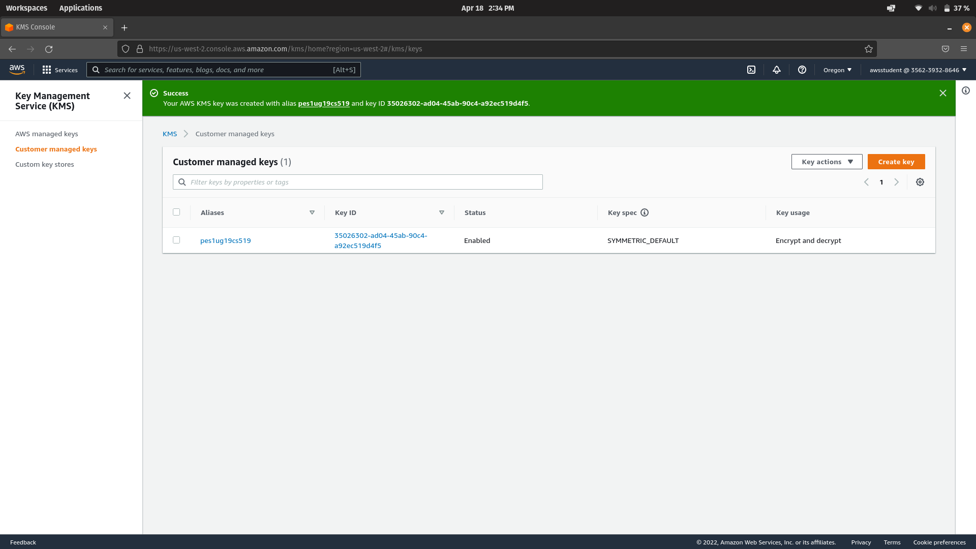

2a.png:
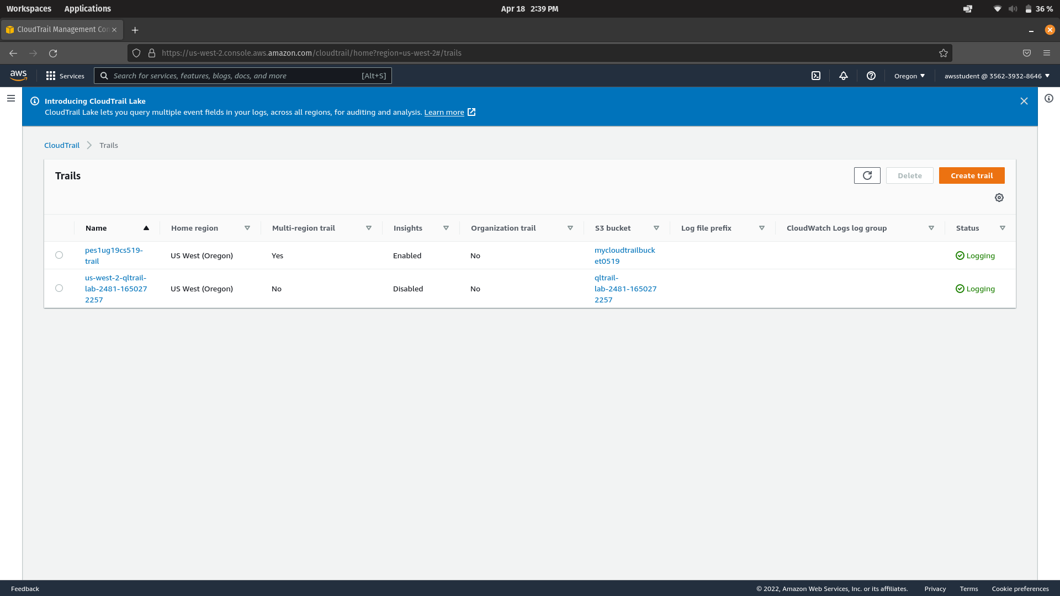
3a.png:
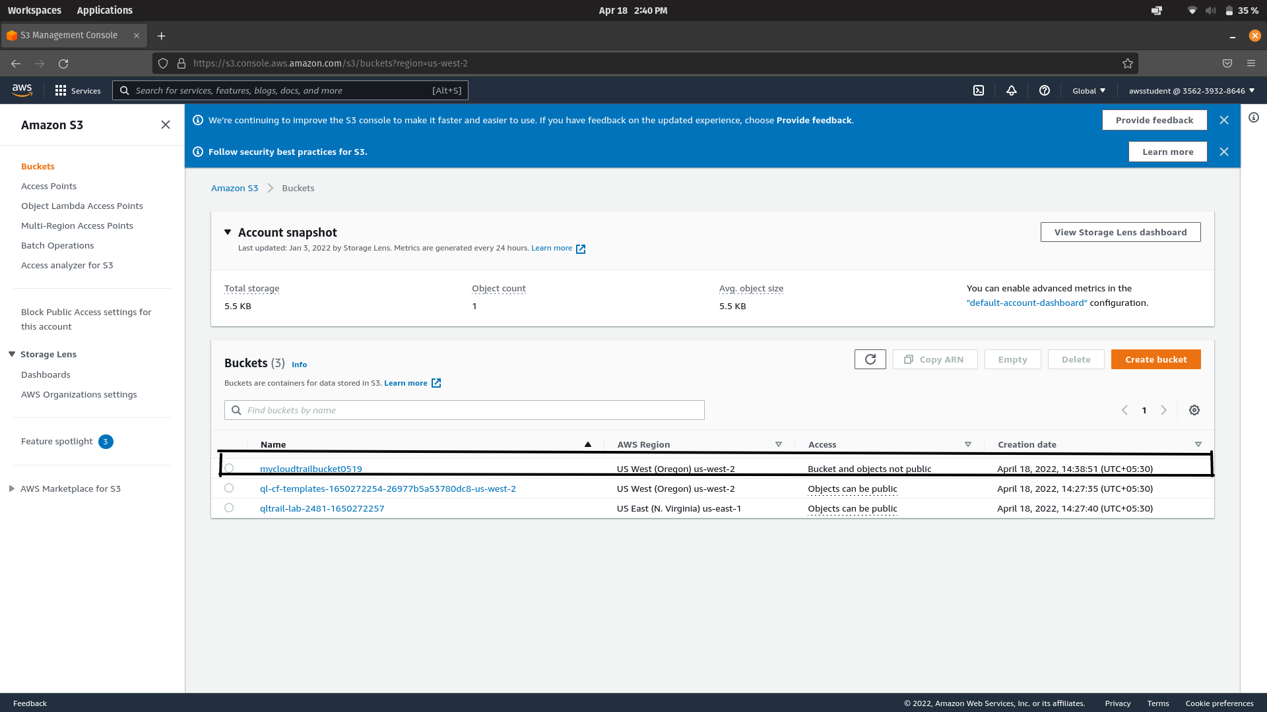
4a.png:
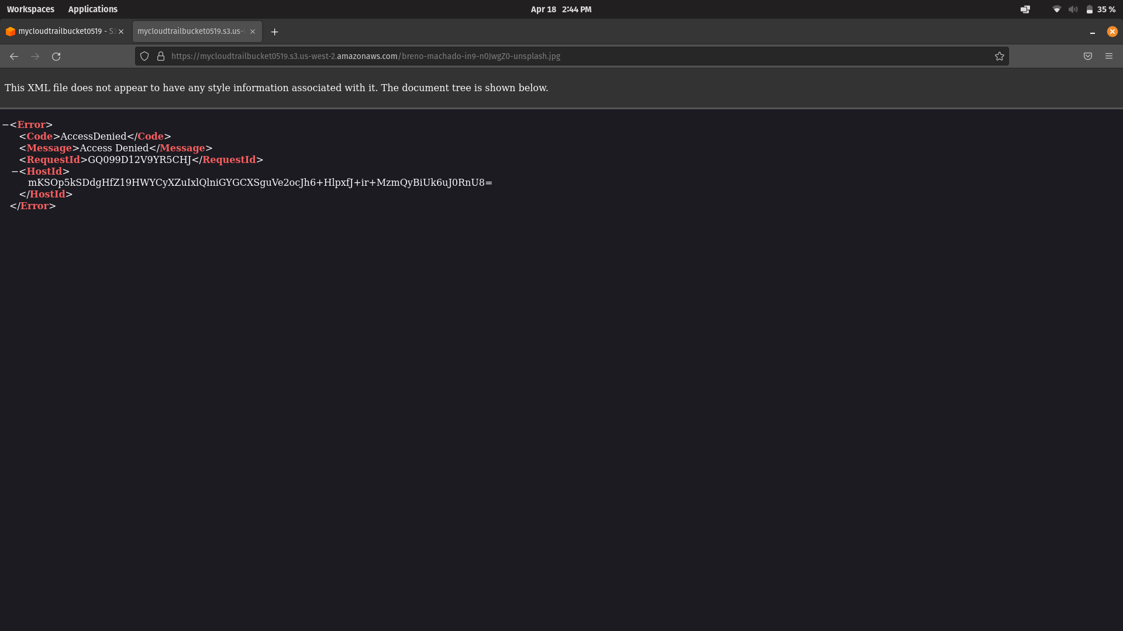
4b.png:
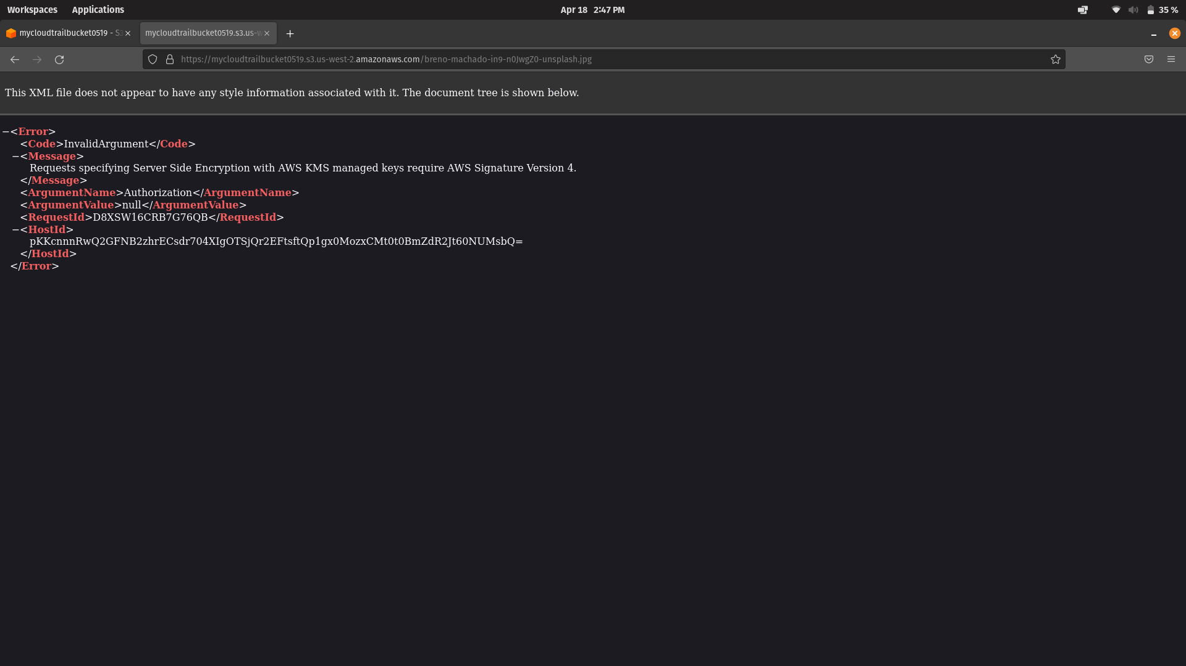
5a.png:
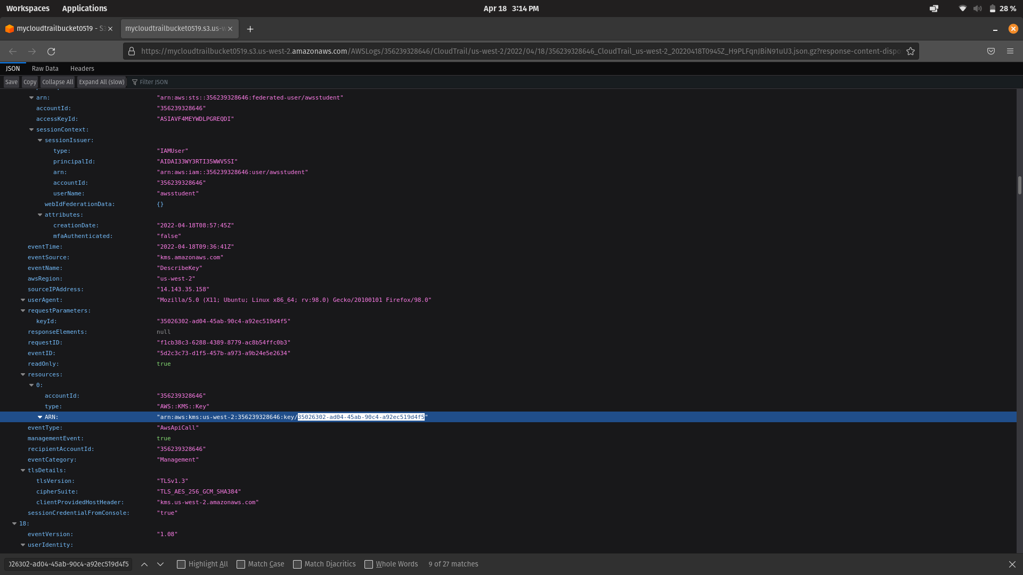
6a.png:
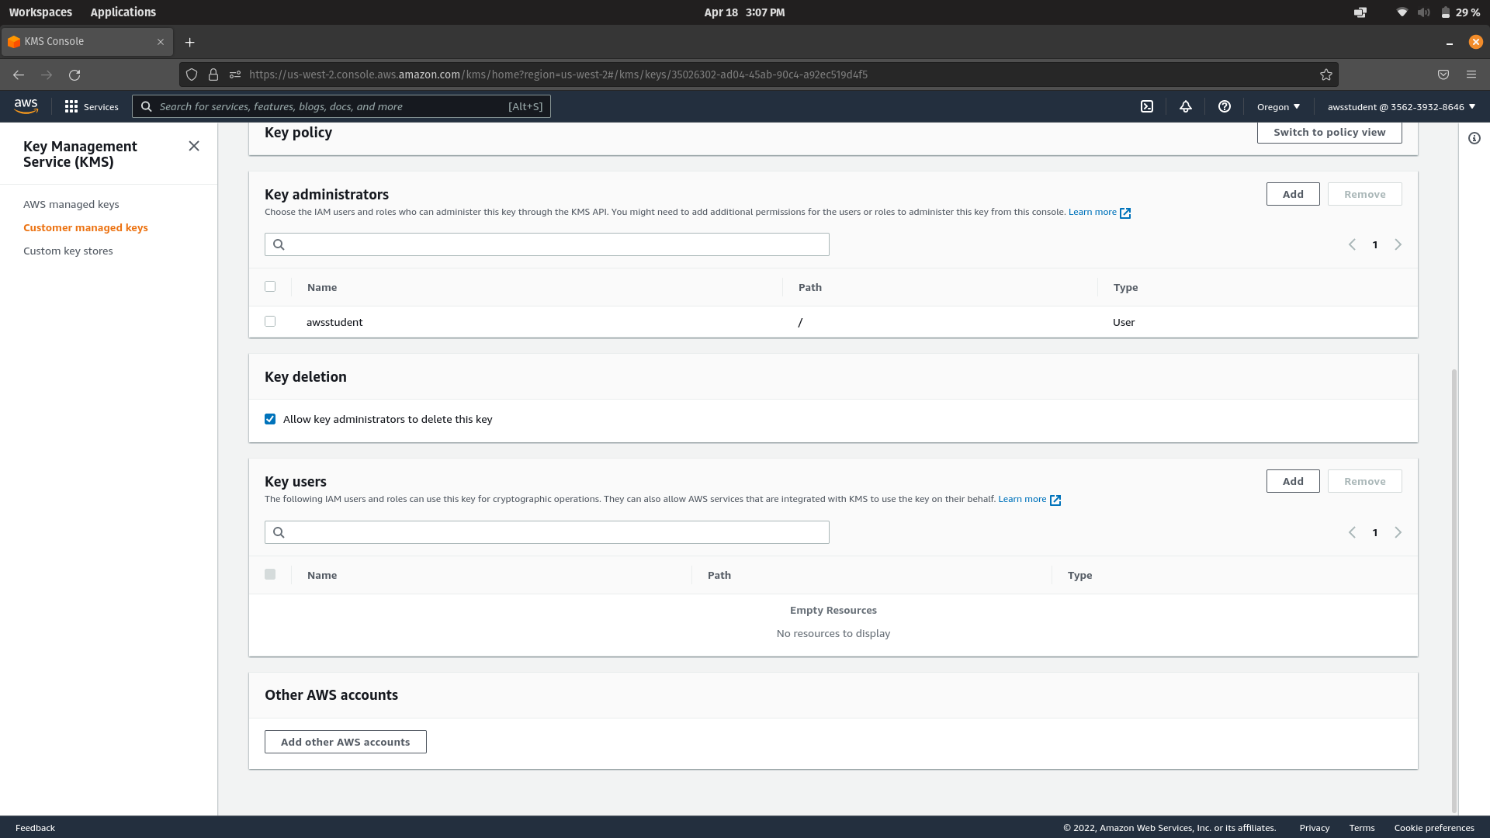
6b.png:
